Interactive Portfolio Website

Student Name: Axel Gumiit

Candidate Number: 262988

Supervisor: Dr Richard Ellis

Introduction

Interactive Websites often features games, videos, images and music. This kind of content is especially fun for users, they get to explore the entire sites by partaking in some actions within the website.

Aims

There are a lot of websites that has been publish since 1991 which accumulate to 1.88 billion already online. (1)(2) 34% of the users around the world interact with 3d visuals over 30 seconds (3) which allow users to be in virtual ready. Building 3d attract people to keep browsing because it is interactive that makes them feel that they are part of the world created within the internet by interacting with it.

For many users prefer 3d visualisation as it offers an immersive experience towards them than having just a traditional website. (1) The software needed to build it but requires skills in a larger scale such as being good as design and learning animations and coding in React as this would create a story due to the motion happening. (4)

For this project I am going to build a website which has some interactive features. I will be exploring human to computer interaction. It will have 3d aspects incorporated in a website making them interactive towards the users. This project will begin with gathering information and researching on different websites that has the same aspect with my project theme and find out how their website is successful so that I can implement it to mine.

Objectives

1. Research and evaluate different website with features such as a moving object, object being able to interact to another object and a 3d portfolios
2. Identify successes and challenges on different websites analysing their review such as how the design look like and why they are designed like that, also what are the drawbacks of having design like those.
3. Research on how a website can be user friendly.
4. Develop a prototype in React to be use later in development
5. Interview people asking them feedback on the prototype and final project
6. Use the feedback from the people and supervisor to improve the project and produce a full evaluation for the project

**Relevance**

This project doesn’t only involve development, it also involves analysis and management of time. It will only not test my technical skills; it will also test my ability to assess my project and act on the feedback for the website. During my second year, I worked with my friends for a software engineering coursework where my role was to design the front end and I enjoyed it which lead me to doing this project because I know that this project will help me improve the skills I needed for the future.

This is relevant to my career as I am trying to be a front-end developer therefore doing good at this project could help me focus on the career path to front-end developer. Having this project on my resume could boost my application and shows the employers project I have done before.

**Timetable**

|  |  |  |  |  |  |  |  |
| --- | --- | --- | --- | --- | --- | --- | --- |
| **Time/Day** | **Mon** | **Tues** | **Wed** | **Thurs** | **Fri** | **Sat** | **Sun** |
| **9:00** |  |  |  |  |  | **Gym** | **Gym** |
| **10:00** | **Lecture** |  | **Lecture** | **Project and coursework** |  |  |  |
| **11:00** | **Lab** | **Meeting with supervisor** |  |  | **Project and CW** | **Project and CW** | **Project and CW** |
| **12:00** | **Lab** |  | **Researching** | **Lecture** |  |  |  |
| **13:00** | **Lab** | **Lecture** |  |  |  |  |  |
| **14:00** | **Lab** |  |  |  |  |  |  |
| **15:00** | **Lecture** | **Project and coursework** |  |  | **Lecture** |  |  |
| **16:00** |  |  | **Project and coursework** |  |  | **Project and CW** | **Project and CW** |
| **17:00** |  |  |  | **Project and Coursework** |  |  |  |
| **18:00** | **Project and coursework** |  |  |  | **Project and CW** |  |  |

**Project Timescale**

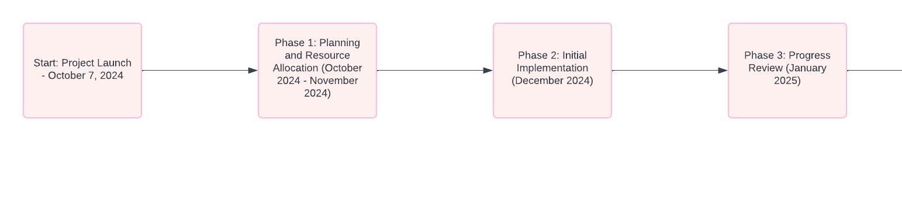

Reference

1. Nix, E. (2016). *The world’s first web site*. [online] History. Available at: https://www.history.com/news/the-worlds-first-web-site.
2. ‌World Economic Forum. (n.d.). This is how many websites there are. [online] Available at: https://www.weforum.org/agenda/2021/08/number-websites-2021-world-wide-web/.
3. ThePro3DStudio. (n.d.). 13 Stats on 3D Product Configurators’ Growth in the Ecommerce Sector. [online] Available at: https://professional3dservices.com/blog/3d-configurators-usage-statistics.html.
4. Anon, (2024). 10 Main Types of Animation with Examples (2024). [online] Available at: https://vidico.com/news/types-of-animation/.